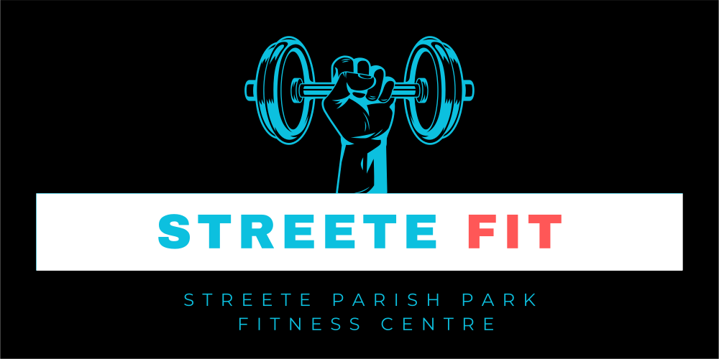
"Exercise not only changes your body, it changes your mind, your attitude and your mood."

POINTS OF NOTE FOR ALL MEMBERS

- Members are restricted on Monday nights to facilitate Bingo from 8.30pm to 10.30pm.
- Membership Costs 2027:
  - Student: €180.
  - Adult: €250.
  - Couple: €475.
- Membership can be paid in a variety of ways:
  - Monthly via Club-Spot: https://streeteanddistrict.ie
  - In Person with Cash.
  - Paid directly into our Bank Account
    - Account: Streete Parish Park.
    - Bank of Ireland IBAN: IE79BOFI90174937980161 BIC: BOFIIE2D.
- Please note charges apply to monthly payments.

1.0 Introduction
Filling out this application form does not guarantee acceptance. It is simply the first step in the application process. We will review your application and may contact you for further information before making a final decision. Committee’s Decision is Final.

The Committee’s decision shall be final. However, in the event that an applicant obtains additional pertinent information, not provided at the time of the initial application, the applicant may re-apply within ten (10) calendar days of the receipt of the decision of the Committee.

The Committee’s decision after consideration of the re-application shall be final. If your application is successful, you may be placed on a waiting list until a vacancy becomes available. Please provide your contact details and other particulars for us to record as part of your membership application.

Remember: A member who feels unwell should not ignore their symptoms or push themselves to continue with exercise activities, but instead, they should call for help, prioritise rest, hydration, and seek medical advice if necessary.

1.1 Applicant’s Details
Please provide the following membership details.

1.2 Emergency Contact(s)

1.2.1 Emergency Contact 1
Please provide contact details whom we should contact in case of an emergency.

1.2.2 Emergency Contact 1
Where possible provide an additional emergency contact in case contact 1 is unavailable.

1.3 Pre-Activity Questionnaire
Please take your time and make sure you are providing accurate details, if you have any questions ask our instructor’s who will be more than happy to help where possible.
- Diabetes
- Asthma
- Arthritis
- Seizures
- Epilepsy

IF YOU ANSWERED 'YES' to any of the above questions, please seek guidance from your GP or appropriate health professional, prior to undertaking physical activity/exercise.

IF YOU ANSWERED 'NO' to all of the above questions and you have no other concerns about your health, you may proceed to undertake light-moderate intensity physical activity/exercise.

1.4 Membership & Conditions

1.4.1 Personal Declaration
I declare that, to the best of my knowledge, there is no medical or other reason preventing me from participating in a gym exercise programme. I confirm that I have completed the Pre-Activity Questionnaire (section 1.3 above) and have disclosed any relevant medical conditions.

I acknowledge that I participate in all gym activities voluntarily and entirely at my own risk, and that I am solely responsible for my health and fitness. I confirm that I have read, understood, and agree to comply with the rules and conditions provided as part of this application. I consent to being included in the Gym What’sApp Group for communication and promotional purposes.

1.4.1.1 New Gym Member

1.4.1.2 Instructor

1.4.1.3 Parent Guardian
If member is aged between 16 to 18 a parent or legal guardian must sign.

2.0 Terms
- To obtain full use of the gym this official Membership application form must be completed and returned to Kevin Brady (Gym Manager) at Streete Parish Park Fitness Centre. Before you use the Gym, a mandatory induction course will be arranged which must be completed. Streete Parish Park Management Committee reserves the right to refuse membership and eject a member from the gym at any time or refuse renewal at the start of a new term. Upon acceptance, membership will only commence when all monies are paid in full or when a reoccurring monthly payment is set up.
- Any member wishing to discontinue or suspend their membership should notify Kevin Brady, (Gym Manager) in writing or by email at kbrady1964@gmail.com. Membership fees paid are non-refundable.
- Please read the rules terms and conditions and agree this membership is right for you.
- Streete Fitness Centre is unmanned and is open 7 days per week from 6am to 12pm. All members are responsible for their own health and safety.

